# Lesson 1 - Calculus (https://www.mathsisfun.com/)

* the study of limits, derivatives, integrals, and infinite series

Algebra – Symbols replace numbers

* Slopes of lines
* Constant speeds and motion
* Areas of triangles/rectangles

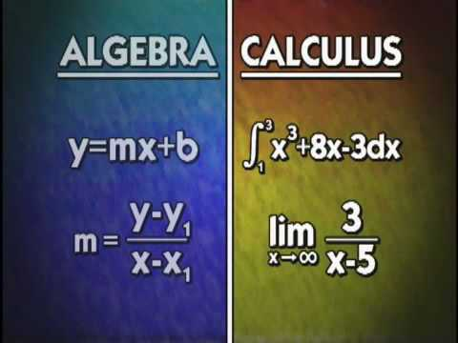

**Calculus** – Mathematics of change (abstract)

* Slopes of curves
* Varying speeds and motion
* Areas of complex objects

## Limits (PRACTICE THESE AS MUCH AS YOU CAN)

* It’s difficult to find the slope (gradient) of a curve at a certain point
* To remedy this, we can estimate the gradient using a sequence of approximations
* The **height** of a function is the **limit value**
* The **length** of the curve is obtained using the limit
* Remember with limits, we need to test from both directions

*NB : indeterminate form is: $\left(\frac{0}{0}\right)$. Any limit that gives you this value is indeterminate/undefined. Generally, if this is your answer find a different way to solve.*

example 1

$f\left(x\right)= \frac{x^{2}-4}{x-2}$ In this equation, is undefined at x = 2. (division by zero)

$\lim_{x→2^{-} f(x)= }{(4)}$ $\lim_{x→2^{+} f(x)= }{(4)}$

Subs these values 1.9 1.999

1.99 1.9999

Subs these values 2.1 2.001

2.01 2.0001

**LH limit** : *y*-value you obtain by approaching *x* from the left side

**RH limit** : *y*-value you obtain by approaching *x* from the right side

* Sometimes the limit in a function does not exist. You can sub values all you want but the result shows that the numbers will not change much. E.g $\lim_{x→2 f(x)= }$ does not exist.

## Limits with cancellation

(Limits as x → c (c $∈$ R))

* Above we were able to find the limit just by subbing in values. Sometimes this doesn’t work so you need to simplify the factors in the fraction.

example 1

$\lim_{x→3 }\frac{x^{2}-9}{x-3}$ = $\frac{0}{0}$ In this fraction we need remove factors

$\lim_{x→3 }\frac{(x-3)(x+3)}{x-3}$ = $\frac{(x+3)}{1}$ = $\frac{(3+3)}{1}$ = 6 therefore $\lim_{x→3 f(x)=6 }$

## Limits to infinity

(Limits as x → ±∞)

* Infinity is not a number but an idea.
* This idea can be seen better with fractions, where $\frac{1}{x}$ and x keeps getting bigger.
* The first step I ssto make sure that the *degree* of the function is greater than 0.

$\lim_{x→∞}\left(\frac{1}{x}\right)$ = 0 The limit of $\frac{1}{x}$ as x approaches infinity is 0.

So what about a normal function?

$\lim_{x→∞}\left(2x\right)= ∞$ The limit is **infinity**

So what about a negative function?

$\lim_{x→-∞}\left(-5x\right)= -∞$ The limit is **negative infinity**

## Limits and degrees

(Limits involving trigonometric functions)

* the degree of the function is the highest exponent in the function
* This is very important as when checking whether the limit is infinity.

*If the degree is 0, the limit is 0.*

* The idea of degrees will help us with understanding rational functions

$f\left(x\right)= \frac{P(x)}{Q(x)}$ Rational function: The ratio of two polynomials

Now we need to compare the degree of P to the degree of Q:

|  |  |
| --- | --- |
| DEGREES | RESULT |
| P < Q | *The limit is 0* |
| P = Q | Degree = ratio of coefficients of terms with largest exponent $\lim_{x→∞}\left(\frac{5x^{2}+1}{3x^{2}-x}\right)$ = $\frac{5}{3}$ $\lim_{x→∞}\left(\frac{4x^{3}+x}{x^{2}-2x^{3}}\right)$ = $\frac{4}{-2}$ = -2 |
| P > Q | The limit is **infinity** *OR* The limit is **negative infinity**  (Evaluate the signs)   * The limit is **infinity $\frac{(x^{3}+2x-1)}{6x^{2}}$**   Highest at the top = $x^{3}$ Highest at the bottom = $6x^{2}$ (both are positive)   * The limit is **negative infinity $\frac{(-2x^{2}+x)}{5x-3}$**   Highest at the top = $-2x^{2}$ = -2  Highest at the bottom = $5x$ = 5  ( $\frac{4}{-2}$ is negative) |

## Limits involving absolute values

* Nothing special here. Remember absolute values reflect distance, so knowing how “close” something is good for understanding the term “approaches” in limits
* The difficult part is just knowing how to write down this idea

example 1

$\lim_{x→1 f(x)= }{2}$ Of the function: $f\left(x\right)= \frac{{(x}^{2}-1)}{x-1}$

f(x) approaches L=2 as x approaches a=1,   
so |f(x)−2| is small when |x−1| is small.

$$\lim_{x→a f(x)= }{L}$$

*a number “x” approaches*

*L the limit*

*Think about a & L as where the “hole” in the graph is.*

* *If you go to the RIGHT of the graph you are going a certain*

*distance away from the hole.*

* *If you go to the LEFT of the graph you are going a certain*

*distance away from the hole.*

Therefore, it does not matter which direction you go, you are still

going a certain distance away from the hole

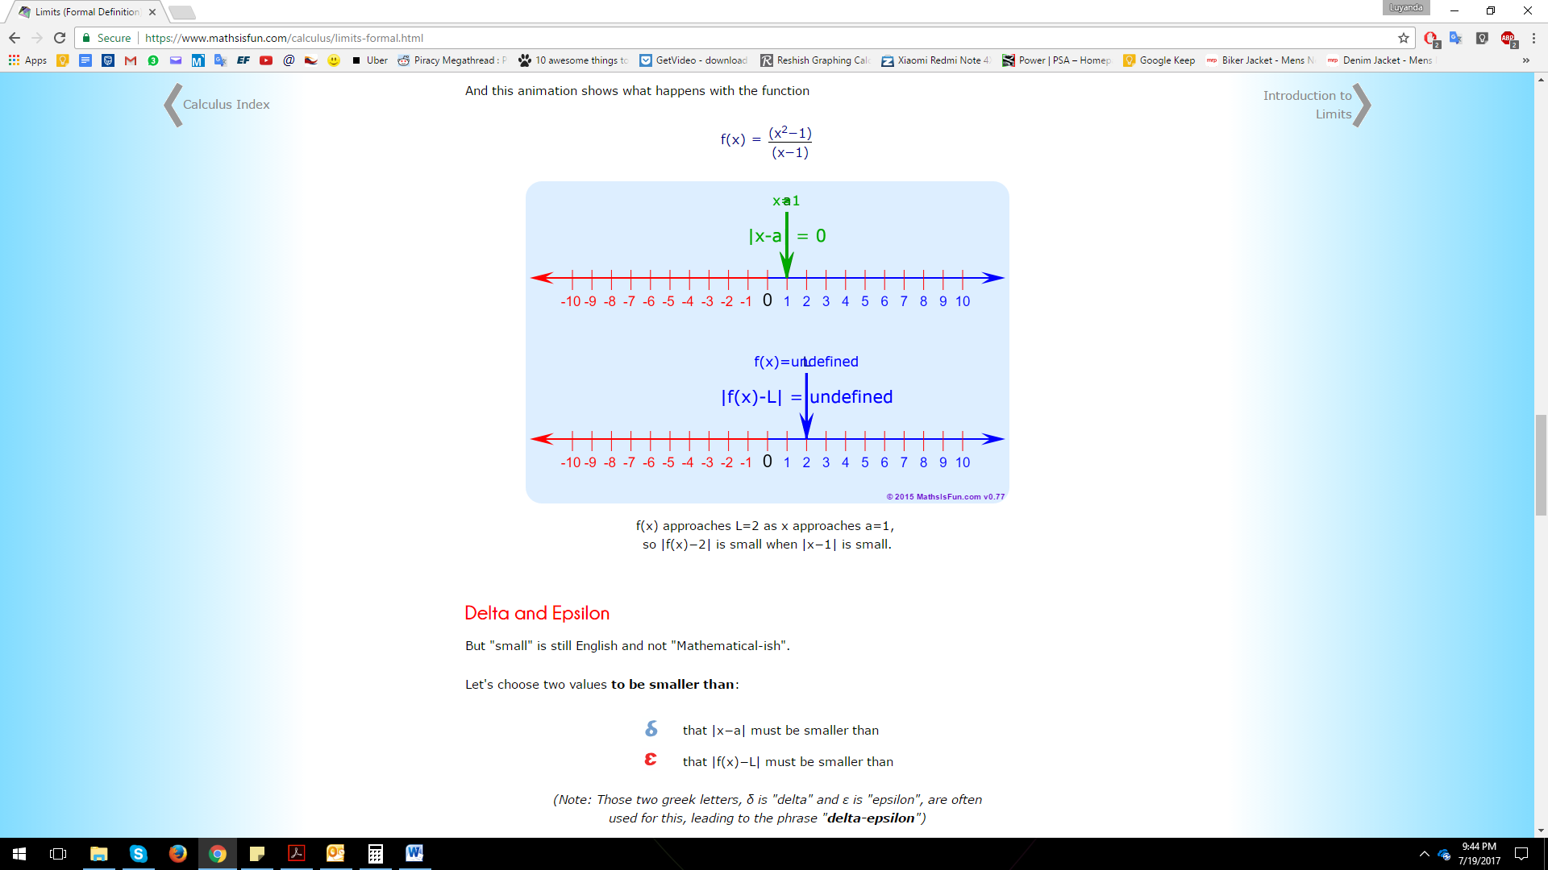 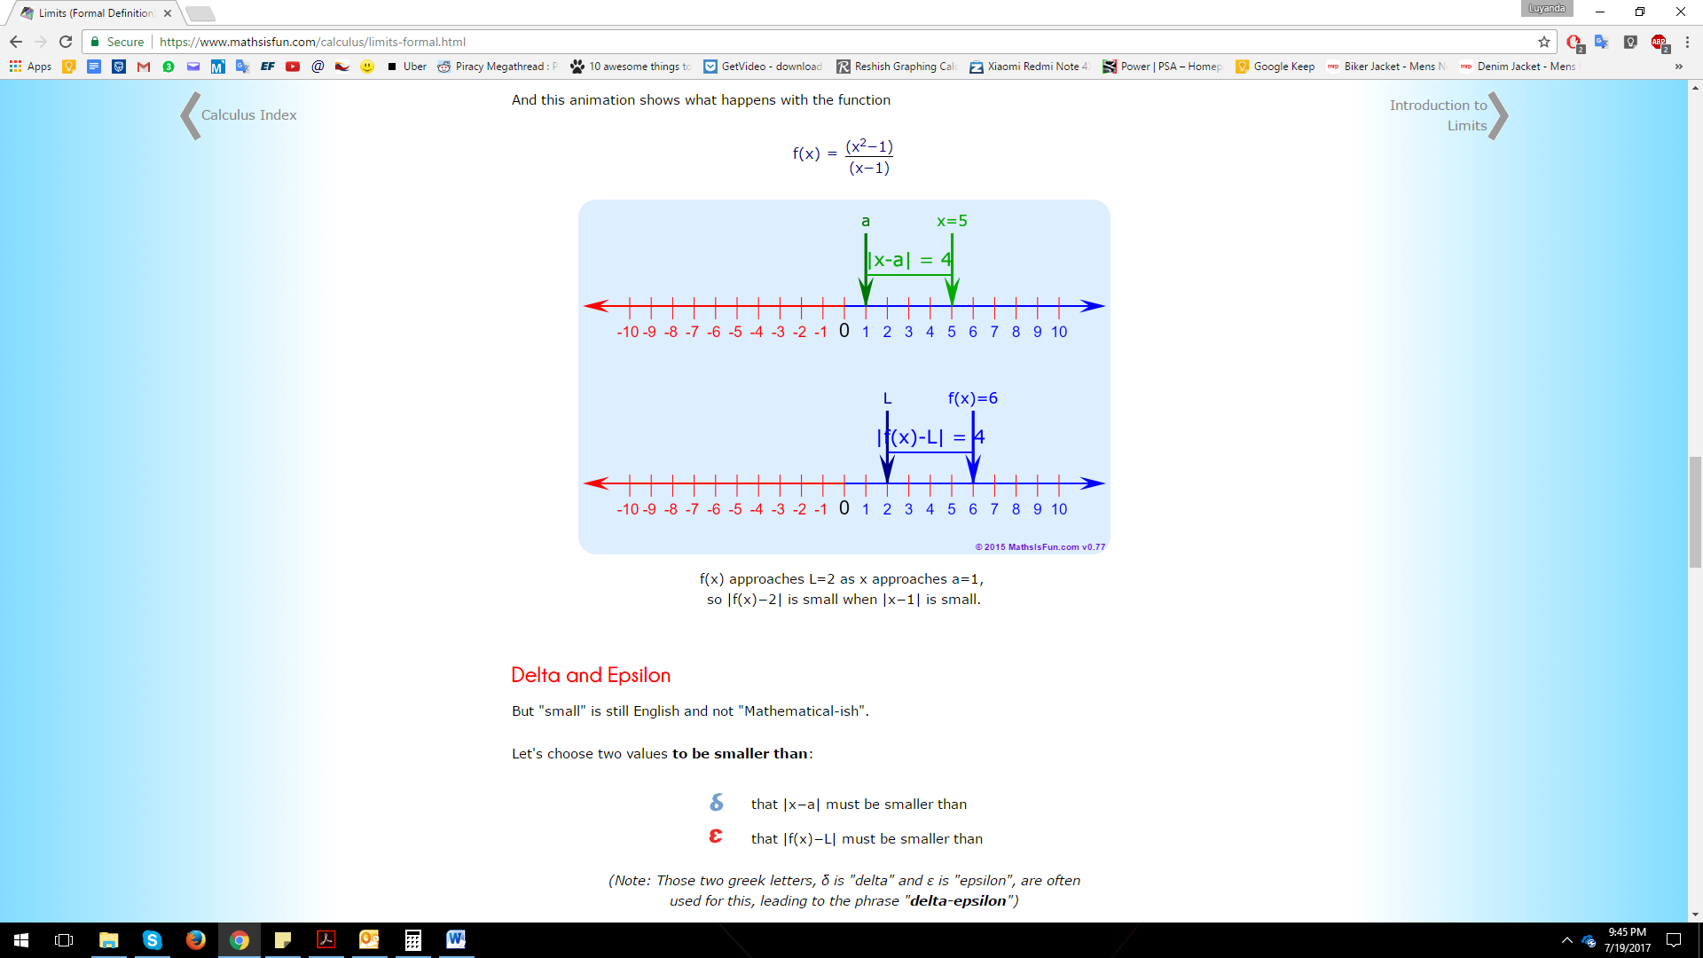

This above one shows where the “hole” in the graph is

This above one shows that the distance away from each point remains the same

## The $ε$ − δ definition of a limit

$ε$ Epsilon: For the y value that |f(x)−L| must be smaller than

$δ$ Delta: For the x value that |x−a| must be smaller than

|f(x)−L|< when |x−a|<

*x so these two are the points where the “hole” is.*

For any $ε$ > 0, there is a $δ$ > 0 so that |f(x)−L|< when |x−a|<

*This is easy. When x gets close to a* then *f(x) gets close to L*

Example 1

$$\lim_{x→3}{2x+4}= 10$$

Step 1 – play with the numbers till you get a formula that might work

To:

|f(x)−L| <

|(2x + 4) − 10| <

|2x - 6| <

2|x - 3| <

|x - 3| < /2

From:

0< | x−a |<

(find a formula for $δ$)

Step 2 - substitute

0< | x−3 |<

0< | x−3 |</2

0< 2| x−3 |<

0< | 2x−6 |<

(but remember that -6 is the as + 4 - 10)

0< | 2x+ 4 - 10|<

*ALWAYS REMEMBER : indeterminate form is: $\left(\frac{0}{0}\right)$. Any limit that gives you this value is indeterminate/undefined. Generally, if this is your answer find a different way to solve.*

# LESSON 2 - How to solve ANY limit: (7 methods)

ALWAYS USE THESE FIRST:

(In order)

1

Plug in “a” value

2

Factor

3

Common Denominator

## 5) Multiply by conjugate (differentiation)

* Cool way of solving that makes solving weird equations easier

Example 1

Conjugate is: ( $\sqrt{x+1}$ +3)

$\lim_{x→8}\left(\frac{\sqrt{x+1}-3}{x-8}\right)$

= $\lim_{x→8}\left(\frac{\sqrt{x+1}-3}{x-8}\right)\frac{\left(\sqrt{x+1}-3\right)}{\left(\sqrt{x+1}-3\right)}$

= $\lim_{x→8}\left(\frac{\sqrt{x+1}-3}{x-8}\right)\frac{\left(\sqrt{x+1}-3\right)}{\left(\sqrt{x+1}-3\right)}$ FINISH THIS!!!

## 6) Limits with trig functions

* Limits of trig functions have two special properties where:

$\lim_{θ→0}\left(\frac{\sin{θ}}{θ}\right)=1$ $\lim_{θ→∞}\left(\frac{\sin{θ}}{θ}\right)=0$

* Use these to solve functions

## 7) Limits with absolute values

* Still part of limits involving absolute values
* Is easy once you know the definition of a piecewise function

A function f is defined by $f\left(x\right)=\left\{\begin{aligned}1-x if x≤1 \\ x^{2} if x>1 \end{aligned}\right\}$*Piecewise definition*

* The above gives you what you should substitute in your limit for the left and right hand side solutions
* Remember if LHS $≠$ RHS, the limit is undefined

## Differentiation

Go back and do differentiation

## l’Hospital’s Rule

* This one is easy to understand, basically the limit of one function over the other is equal to the limit of the derivative of the first function over the derivative over the other.
* Use this when we have one function over the other (usually with trig functions)

## 

## The Squeeze Theorem

* Not too bad, this method looks at functions that are “squeezed” together.
* Some functions may have an intersect but instead of the having one point where the cut each other, we might have something like two curves bending together and we need to see the limit where they are close to each other

Squeeze theorem:

$if f(x)$ $≤h(x)$ $≤g(x)$

then

$$\lim_{x→a}{g\left(x\right)=L= }\lim_{x→a}f(x)$$

The difficult part comes with trig signs

## Continuity

* This is also pretty easy to understand. We’re basically testing if all the graphs given to us have continuity i.e. no spaces/don’t diverge as we move from the left to right
* When you are given multiple plotted graphs sometimes there are breaks or open spaces
* To test if there is a break we basically need to test the LHS (-) with the RHS (+) limit and see if they are equal

# Lesson 3 - Derivatives

* LEARN HOW TO TAKE CONSTANT OUT i.e. $(a.f')=a.f'$
* Also not too hard, remember notes from high school
* It’s basically finding the slope/gradient of the original function
* This is important as you get VERY complicated functions so we need a way to calculate the gradient of the function without the crazy high degrees

*NB, dy/dx is NOT the same as d/dx. The former is used in the chain rule and implicit differentiation*

#### Some revision first

$\frac{dy}{dx} [cx]$*= c*

$\frac{dy}{dx} [x]$*= 1 derivative of x is 1*

$\frac{dy}{dx} [c]$*= 0 derivative of s constant is 0*

## 1) Power rule

POWER RULE:

$\frac{d}{dx}(x^{n})$ = $nx^{n-1}$

* Bread and butter of derivatives
* Used with other rules too
* Apply to all terms of a derivative

## 2) Product rule

PRODUCT RULE:

$\frac{d}{dx} (uv)$ = $u$ $\frac{dv}{dx}$ + $v\frac{du}{dx}$

* asasadas

## 3) Chain rule

CHAIN RULE:

$\frac{df\left(u\right)}{dx}$ = $\frac{df}{du}$. $\frac{du}{dx}$

* Find dy/dx “Find the derivative”
* Saves a LOT of time
* Use on composition functions, where factoring or

FOIL would be too tedious

AKA ***OUTSIDE INSIDE*** RULE

$\frac{dy}{dx}$ = $\left(\begin{aligned}derivative of \\ OUTSIDE \\ function, leave \\ inside alone\end{aligned}\right).\left(\begin{aligned}derivative of \\ INSIDE \\ function, \\ \end{aligned}\right)$

|  |  |
| --- | --- |
| $${\left(3x+1\right)}^{7}$$ | ✔ Composite function |
| $$\left(3x+1\right)$$ | ✘ Not composite function |
| $$x^{7}$$ | ✘ Not needed |
| $${\left(x+1\right)}^{7}$$ | ✔ Doesn’t do much but DO IT |
| $${\left(x^{2}+1\right)}^{7}$$ | ✔ Composite function |

Example 1 ***Do you need the chain rule?***

***Power rule***

$y$ = ${\left(3x+1\right)}^{7}$

$\frac{dy}{dx}$ = $7{\left(3x+1\right)}^{6}$.(3)

$\frac{dy}{dx}$ = $21{\left(3x+1\right)}^{6}$

QUOTIENT RULE:

$\frac{d}{dx}\left(\frac{u}{v}\right)$ = $\left(\frac{V\frac{du}{dx}-u\frac{dv}{dx}}{v^{2}}\right)$ (if v $≠$ 0)

## 4) Quotient Rule

Sddassad

## 5) Implicit differentiation (x AND y in equation)

* This is used for equations where we have x and y

Example 1

$x^{2}+y^{2}=36$

= $2x+2y\frac{dy}{dx}=0$

= $2y\frac{dy}{dx}=-2x$

= $\frac{dy}{dx}=\frac{-2x}{2y}$

= $\frac{dy}{dx}=\frac{x}{y}$

# Lesson 4 - Integration

* LEARN HOW TO TAKE CONSTANT OUT i.e. $\int{a.f\left(x\right)dx}= a.\int{f\left(x\right)dx}$
* Basically the opposite of differentiation/finding the derivative
* We are looking for the indefinite integral / integral / anti derivative

Integrate

$\int{2x.dx }$ = $x^{2}+c$

Take

Derivative

$\frac{d}{dx}\left(x^{2}\right)$ = $2x$

$x^{2}$ $x^{2}$

$2x$ $2x$

## 1) Power rule

POWER RULE:

$\int{x^{n}.dx }$ = $\frac{x^{n+1}}{n+1}+c$

$$n≠ -1$$

* Bread and butter of integration too
* Used with other rules too
* Use ONLY if your power is not -1
* Apply to all terms of an integral

Example 1

*Placeholder for all possible anti-derivatives*

$\int{\left(x^{3}-6x^{2}+x+1\right)dx }$

= $\frac{x^{4}}{4}$- $\frac{6x^{3}}{3}$ + $\frac{x^{2}}{2}$ + $1x$ + $c$

= $\frac{x^{4}}{4}$- $2x^{3}$ + $\frac{x^{2}}{2}$ + $x$ + $c$

## 2) U-substitution

Example 1

Example 2

Example 3

$\int{x\sqrt{x+2}dx }$ chose “u expression”, in this case x+2 because its’ underneath the radical

Also make du = dx

Replace x by manipulating “u = x+2” -> x =u-2

= $\int{(u-2) \sqrt{u}}du$

= $\int{\left(u-2\right)u^{\frac{1}{2}}}du$

= $\int{{(u}^{\frac{3}{2}}-2u^{\frac{1}{2}}})du$ Multiply out

= $\frac{u^{\frac{5}{2}}}{\frac{5}{2}}-\frac{2u^{\frac{3}{2}}}{\frac{3}{2}}+c$ Now we can use the power rule

= $\frac{2}{5}u^{\frac{5}{2}}-\frac{4}{3}u^{\frac{3}{2}}+c$ Simplify

= $\frac{2}{5}{(x+2)}^{\frac{5}{2}}-\frac{4}{3}{(x+2)}^{\frac{3}{2}}+c$ Plug in “x+2” everywhere u appears

Example 4